
Scalable Web Application on AWS Elastic Beanstalk
Docker, Amazon ECR, Application Load Balancer and Auto Scaling (Python Flask)
Item | Details
Platform | AWS Elastic Beanstalk, Docker running on 64bit Amazon Linux 2023
Application | Python Flask served by Gunicorn, packaged as one Docker image
Registry | Amazon ECR (private repository menna-ecr)
Region | us-east-1
Capacity | t3.micro instances, minimum 2 and maximum 4, Auto Scaling on CPU utilization
Document version | 1.0
Status | Draft
Prepared by | Team A - 2
Date | 2026-10-04

Document Version and Change Log
Version | Date | Author | Description of change
1.0 | 2026-10-04 | Team A - 2 | Initial release: Flask app, Docker image, private ECR repository, Elastic Beanstalk deployment with Application Load Balancer, health checks and Auto Scaling, testing and validation checklist

1. Project Overview and Architecture
The goal of this task is to deploy a scalable web application on AWS using Elastic Beanstalk. The application is built with Python Flask, containerized with Docker, stored in a private Amazon ECR repository and deployed through AWS Elastic Beanstalk (EB).
Elastic Beanstalk manages the application environment: the EC2 instances, the Application Load Balancer (ALB), the health checks and Auto Scaling. The environment runs a minimum of 2 instances and scales up to 4 instances based on CPU utilization.
Component | Image / Resource | Port | Role
App (Flask) | 897192298286.dkr.ecr.us-east-1.amazonaws.com/menna-ecr:latest | 5000 (container) | Serves the web page and the /health endpoint with Gunicorn
ALB | Public Application Load Balancer | 80 (HTTP) | Receives user traffic and forwards it to healthy instances
EC2 | t3.micro, x86_64 | 5000 | Runs the Docker container pulled from ECR
Auto Scaling | Min 2 / Max 4 | n/a | Adds or removes instances based on CPU utilization

Architecture
Internet
|
v http://<environment-name>.us-east-1.elasticbeanstalk.com
Application Load Balancer (HTTP :80, health check: /health)
|
+--------------------+--------------------+
v v
EC2 #1 (t3.micro) EC2 #2 (t3.micro)
| |
v v
Docker container (:5000) Docker container (:5000)
| |
v v
Flask app (Gunicorn) Flask app (Gunicorn)

Amazon ECR (menna-ecr) --(image pulled on deploy)--> EC2 instances

Prerequisites
- AWS account with permissions for Elastic Beanstalk, EC2, ECR, ELB, Auto Scaling and IAM.
- AWS CLI installed and configured (aws configure).
- Docker installed locally.
- Python installed locally.
- Git (optional).
- The AWS Region used in this project is us-east-1.

2. Step 1: Create the Application and Docker Image

2.1 Project structure
elastic-beanstalk-app/
├── app.py
├── requirements.txt
├── Dockerfile
└── Dockerrun.aws.json

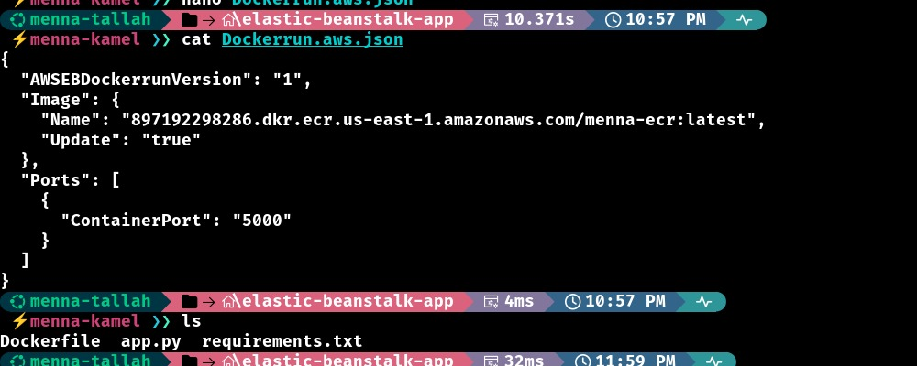
Figure 1: Project folder with app.py, requirements.txt, Dockerfile and Dockerrun.aws.json

2.2 Flask application
The application provides two endpoints. The / endpoint displays the application name, the Flask status, the server hostname and the port. The hostname is important because it lets you verify that requests are distributed between different EC2 instances. The /health endpoint is used by the Application Load Balancer and returns OK with HTTP status 200.
app.py
from flask import Flask
import socket

app = Flask(__name__)

@app.route("/")
def home():
hostname = socket.gethostname()
return f"""
<h1>Hello from Flask!</h1>
<h2>AWS Elastic Beanstalk</h2>
<p>Hostname: {hostname}</p>
<p>Port: 5000</p>
<p>Status: Application is running</p>
"""

@app.route("/health")
def health():
return "OK", 200

if __name__ == "__main__":
app.run(host="0.0.0.0", port=5000)

2.3 requirements.txt
requirements.txt
Flask==3.1.2
gunicorn==23.0.0

Why Gunicorn? Flask's built-in development server is not intended for production use. Gunicorn is used as the production WSGI server.

2.4 Dockerfile
The Dockerfile uses the Python 3.12 slim image, sets /app as the working directory, installs the dependencies, copies the Flask application, exposes port 5000 and starts Gunicorn on 0.0.0.0:5000.
Dockerfile
FROM python:3.12-slim
WORKDIR /app
COPY requirements.txt .
RUN pip install --no-cache-dir -r requirements.txt
COPY app.py .
EXPOSE 5000
CMD ["gunicorn", "--bind", "0.0.0.0:5000", "app:app"]

2.5 Build the Docker image
From the project directory, build the image and verify that it appears locally.
docker build -t menna-ecr .
docker images

2.6 Create the Amazon ECR repository
Create a private ECR repository in the console (Amazon ECR > Private repositories > Create repository) with these values:
Setting | Value
Visibility | Private
Repository name | menna-ecr
Region | us-east-1
Repository URI | 897192298286.dkr.ecr.us-east-1.amazonaws.com/menna-ecr

2.7 Authenticate, tag and push the image
Authenticate Docker with ECR. The expected output is Login Succeeded.
aws ecr get-login-password --region us-east-1 | \
docker login --username AWS \
--password-stdin 897192298286.dkr.ecr.us-east-1.amazonaws.com

Tag the local image with the ECR repository URI and verify it:
docker tag menna-ecr:latest \
897192298286.dkr.ecr.us-east-1.amazonaws.com/menna-ecr:latest

docker images

Push the image:
docker push \
897192298286.dkr.ecr.us-east-1.amazonaws.com/menna-ecr:latest

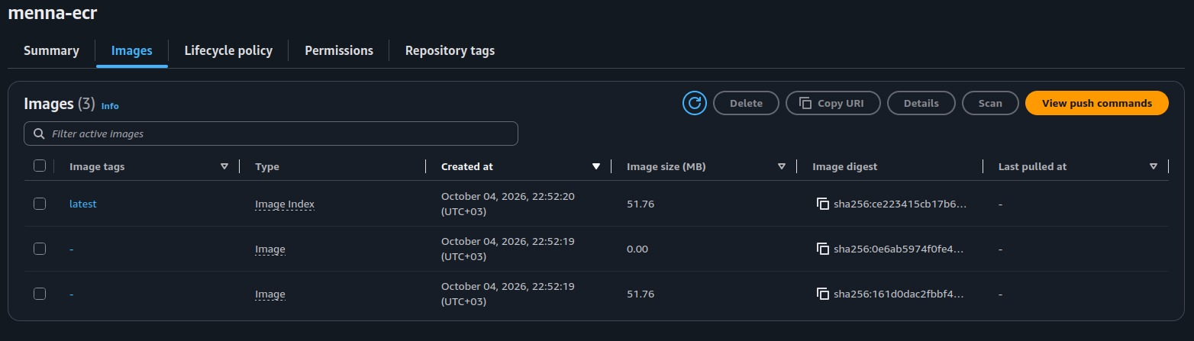

2.8 Allow Elastic Beanstalk to pull from ECR
- Open IAM > Roles and find aws-elasticbeanstalk-ec2-role.
- Choose Add permissions > Attach policies.
- Attach AmazonEC2ContainerRegistryReadOnly.
The permission is attached to the EC2 instance role, not to the ECR repository itself. The permission flow is:
Elastic Beanstalk
|
v
EC2 instance
|
v
aws-elasticbeanstalk-ec2-role
|
v
AmazonEC2ContainerRegistryReadOnly
|
v
Private ECR --> Docker image
{
"Version": "2012-10-17",
"Statement": [
{
"Effect": "Allow",
"Action": [
"ecr:GetAuthorizationToken",
"ecr:BatchCheckLayerAvailability",
"ecr:GetDownloadUrlForLayer",
"ecr:GetRepositoryPolicy",
"ecr:DescribeRepositories",
"ecr:ListImages",
"ecr:DescribeImages",
"ecr:BatchGetImage",
"ecr:GetLifecyclePolicy",
"ecr:GetLifecyclePolicyPreview",
"ecr:ListTagsForResource",
"ecr:DescribeImageScanFindings"
],
"Resource": "*"
}
]
}

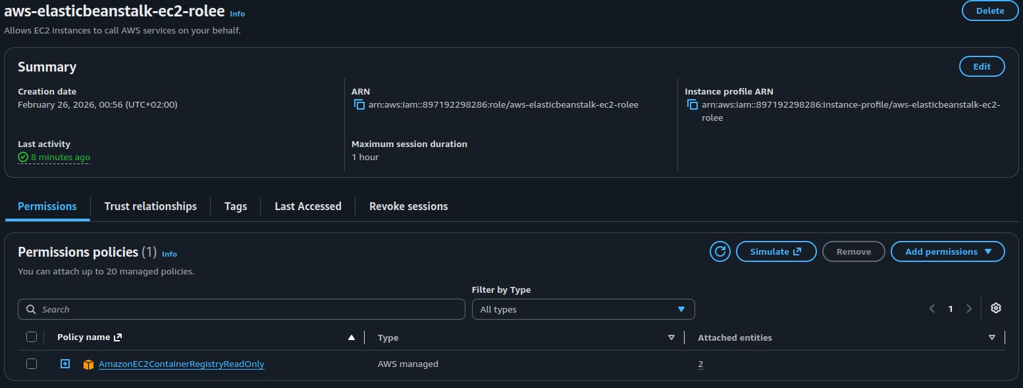
Figure 6: AmazonEC2ContainerRegistryReadOnly attached to the Elastic Beanstalk EC2 role

2.9 Create Dockerrun.aws.json
Elastic Beanstalk needs to know which Docker image to deploy. This file points to the image in ECR and the container port.
Dockerrun.aws.json
{
"AWSEBDockerrunVersion": "1",
"Image": {
"Name": "897192298286.dkr.ecr.us-east-1.amazonaws.com/menna-ecr:latest",
"Update": "true"
},
"Ports": [
{
"ContainerPort": "5000",
"HostPort": "5000"
}
]
}

Important: The Docker image already contains app.py, requirements.txt and the Dockerfile contents. These files do not need to be included in the Elastic Beanstalk deployment ZIP.

2.10 Create the deployment ZIP
The deployment bundle contains only Dockerrun.aws.json.
zip elastic-beanstalk-app.zip Dockerrun.aws.json
unzip -l elastic-beanstalk-app.zip

3. Step 2: Deploy Using the Elastic Beanstalk Console
- Sign in to the AWS Console, open Elastic Beanstalk, confirm the Region is us-east-1 and click Create application.
- Environment tier: select Web server environment. Application name: menna-elastic-app.
- Platform: choose Docker, platform branch Docker running on 64bit Amazon Linux 2023, and use the recommended platform version.
- Application code: select Upload your code and upload elastic-beanstalk-app.zip.
- Service access: service role aws-elasticbeanstalk-service-role and EC2 instance profile aws-elasticbeanstalk-ec2-role.
- Networking: select the default VPC and choose multiple Availability Zones for the instances (for example us-east-1a, us-east-1b and us-east-1c).
- Instances: instance type t3.micro, architecture x86_64. Capacity: minimum 2 and maximum 4 instances.
Why the instance profile matters: aws-elasticbeanstalk-ec2-role carries the ECR read permission that the instances need to pull the private Docker image.
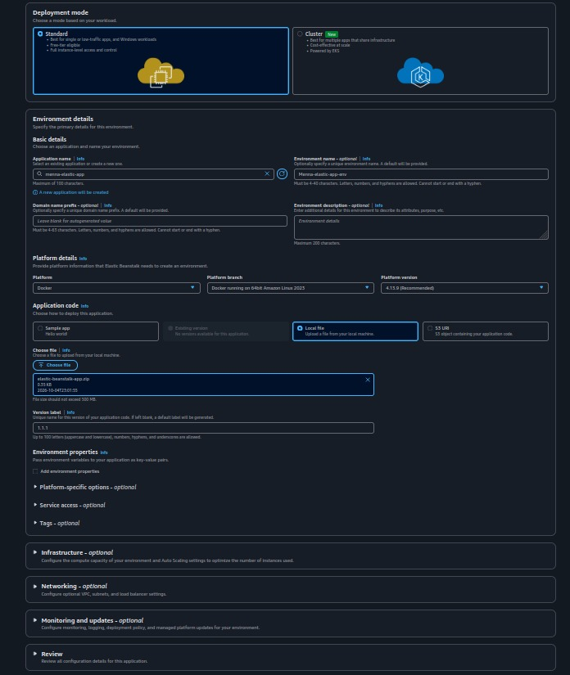
Figure 8: Create application page with Web server environment
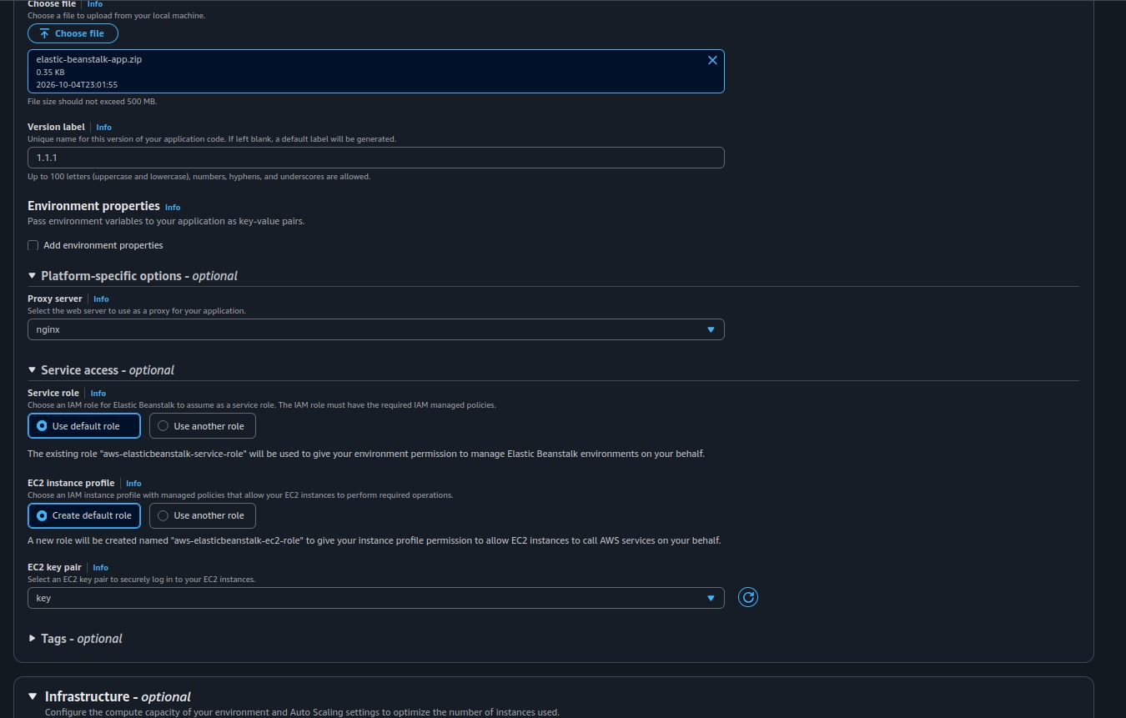

4. Step 3: Enable Auto Scaling
Configure the scaling trigger in the Capacity section of the environment configuration, using the values below.
Setting | Value | Notes
Scaling type | Manual configuration | Explicit thresholds instead of a preset
Metric | CPUUtilization | Statistic: Average
Period | 5 minutes | How often the metric is evaluated
Scale out (upper threshold) | 70% | Add instances when CPU reaches 70%
Scale in (lower threshold) | 30% | Remove instances when CPU falls below 30%
Scale-up increment | 1 instance | One instance is added at a time
Scale-down increment | 1 instance | One instance is removed at a time
Cooldown | 300 seconds | Wait time between scaling activities
Minimum / Maximum instances | 2 / 4 | The environment never goes outside this range

Scaling behavior
2 instances
| CPU > 70%
v
3 instances
| CPU > 70%
v
4 instances (maximum)

When the workload decreases: 4 -> 3 -> 2 (minimum)

Using at least two instances allows the Application Load Balancer to distribute traffic between multiple servers.
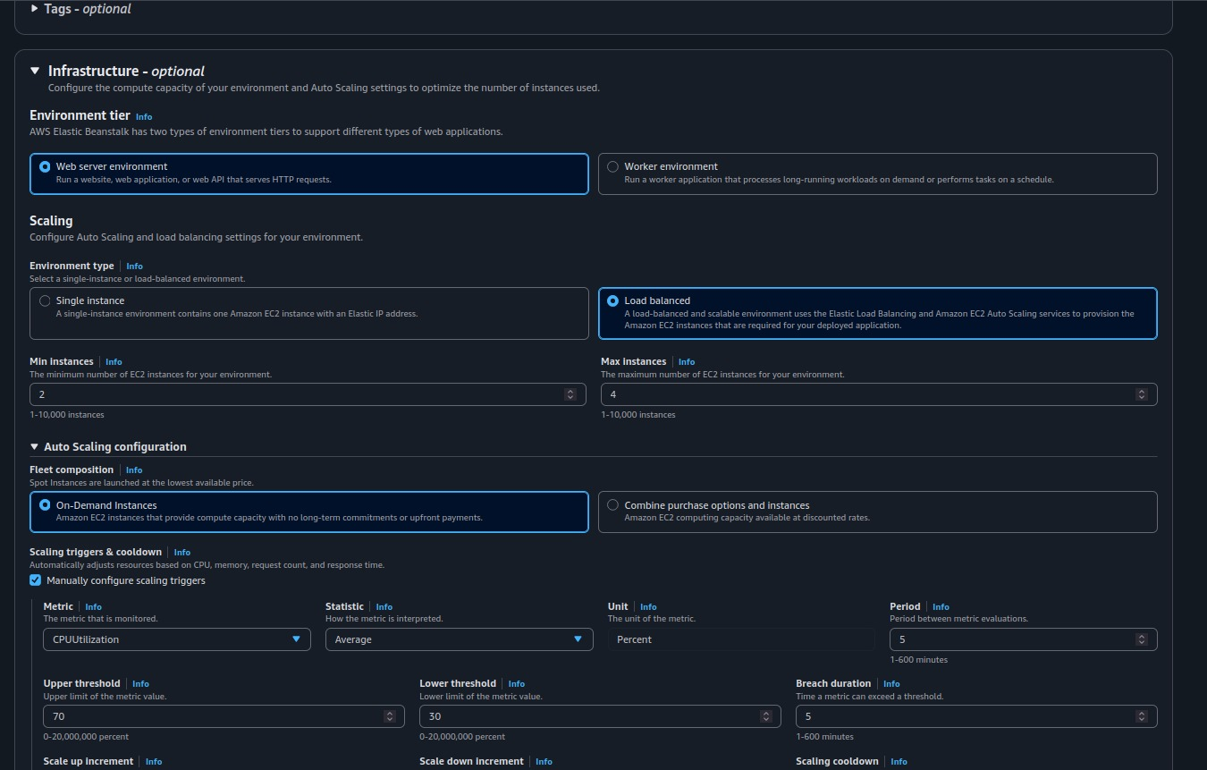
Figure 13: Capacity section with Min = 2 and Max = 4
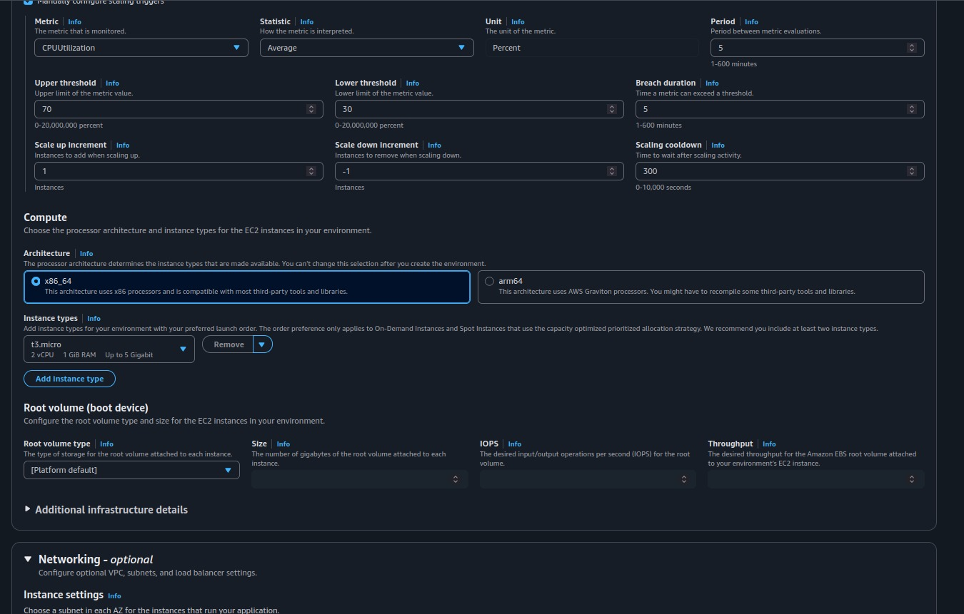
Figure 14: Scaling triggers: CPUUtilization thresholds

5. Step 4: Configure the Load Balancer, Process and Network

5.1 Application Load Balancer
Setting | Value
Load balancer | Application Load Balancer
Type | Dedicated
Scheme | Public
Listener | HTTP :80

Users access the Elastic Beanstalk URL on port 80. The ALB forwards the traffic to the application running inside the Docker containers.
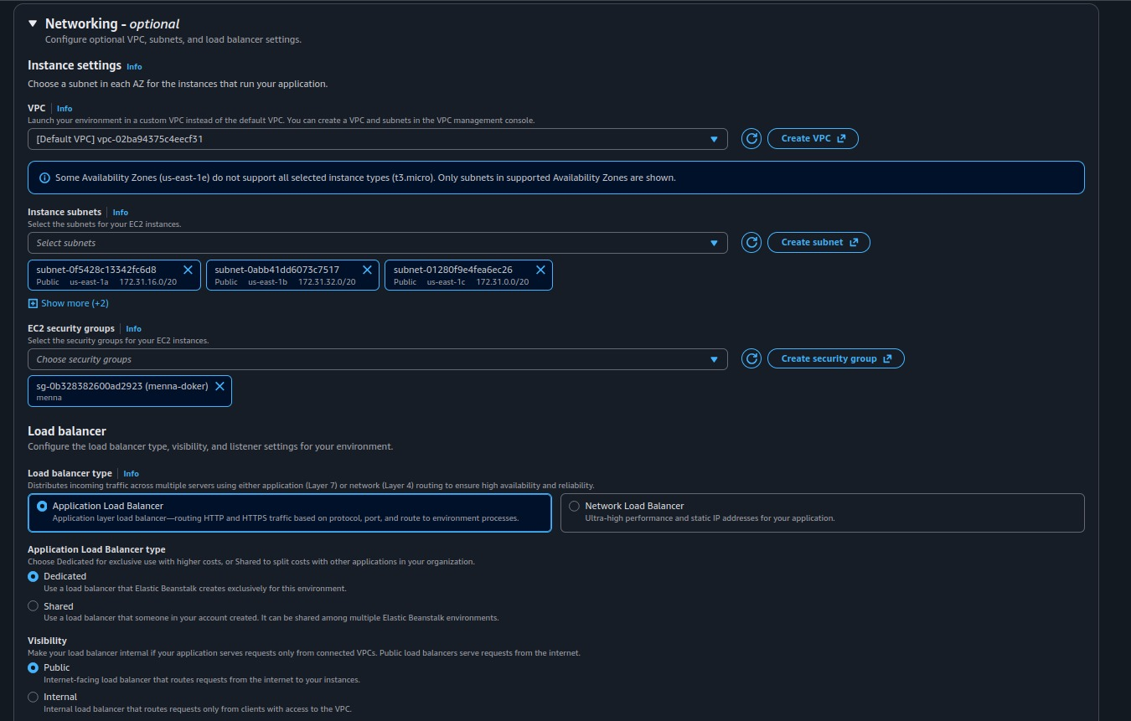
Figure 15: Load balancer configuration: ALB and HTTP :80 listener

5.2 Beanstalk process
The default process must match the port exposed by the Docker container.
Setting | Value
Process name | default
Port | 5000
Protocol | HTTP
Health check path | /health
Expected HTTP code | 200

Client
|
v
ALB :80
|
v
EC2 :5000
|
v
Docker :5000
|
v
Flask

5.3 Health checks
The ALB periodically calls /health. The Flask application returns OK with HTTP 200. If an EC2 instance stops responding correctly, the ALB marks it unhealthy and stops sending normal application traffic to it, so users are not routed to unhealthy instances.

5.4 Networking
Use the default VPC. Select multiple Availability Zones for the EC2 instances (for example us-east-1a, us-east-1b and us-east-1c). The Application Load Balancer also uses multiple Availability Zones, which improves availability.

5.5 Security groups
The ALB accepts public HTTP traffic on TCP 80, and the EC2 instances accept application traffic from the ALB on TCP 5000.
Internet
| TCP 80
v
ALB Security Group
| TCP 5000
v
EC2 Security Group

Production tip: For a production environment, port 5000 should be allowed only from the ALB security group rather than from the entire internet.
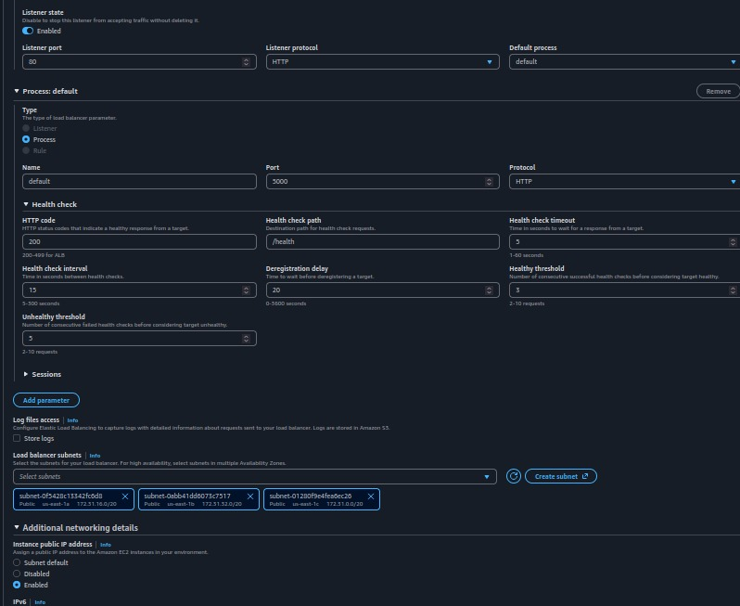

6. Step 5: Create the Environment and Monitor the Deployment
After reviewing the configuration, choose Create environment. Elastic Beanstalk provisions the Application Load Balancer, the EC2 instances, the Auto Scaling configuration, the target group, the security-related resources, the Docker environment and the application deployment. The EC2 instances pull menna-ecr:latest from Amazon ECR.
Open Elastic Beanstalk > Environment > Events to monitor the deployment. Wait until the environment becomes healthy.
Creating environment
|
v
Launching instances
|
v
Configuring load balancer
|
v
Deploying application
|
v
Health checks
|
v
Environment ready

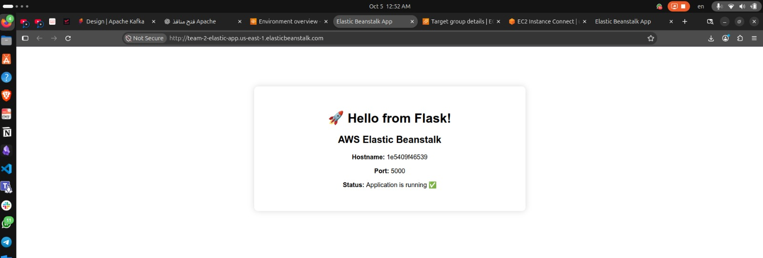
Figure 18: Successful access to the web application
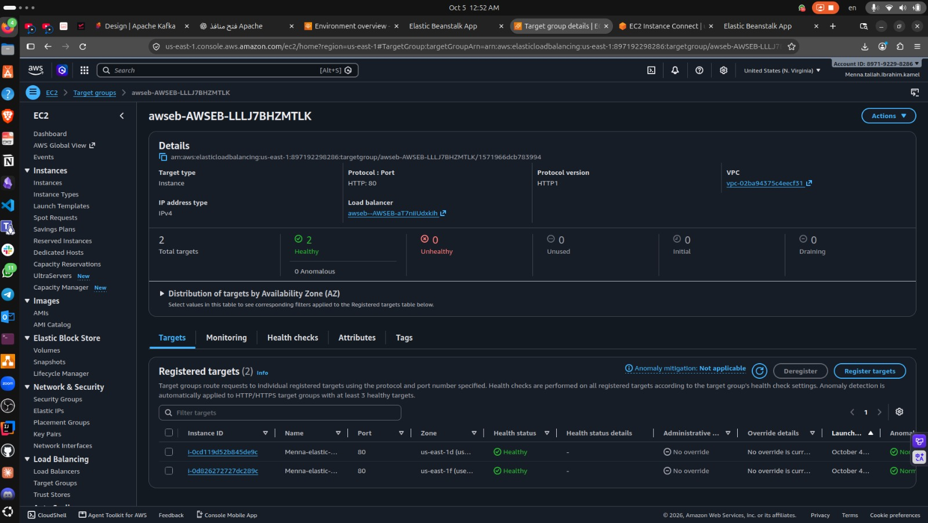
Figure 19: Target Groups
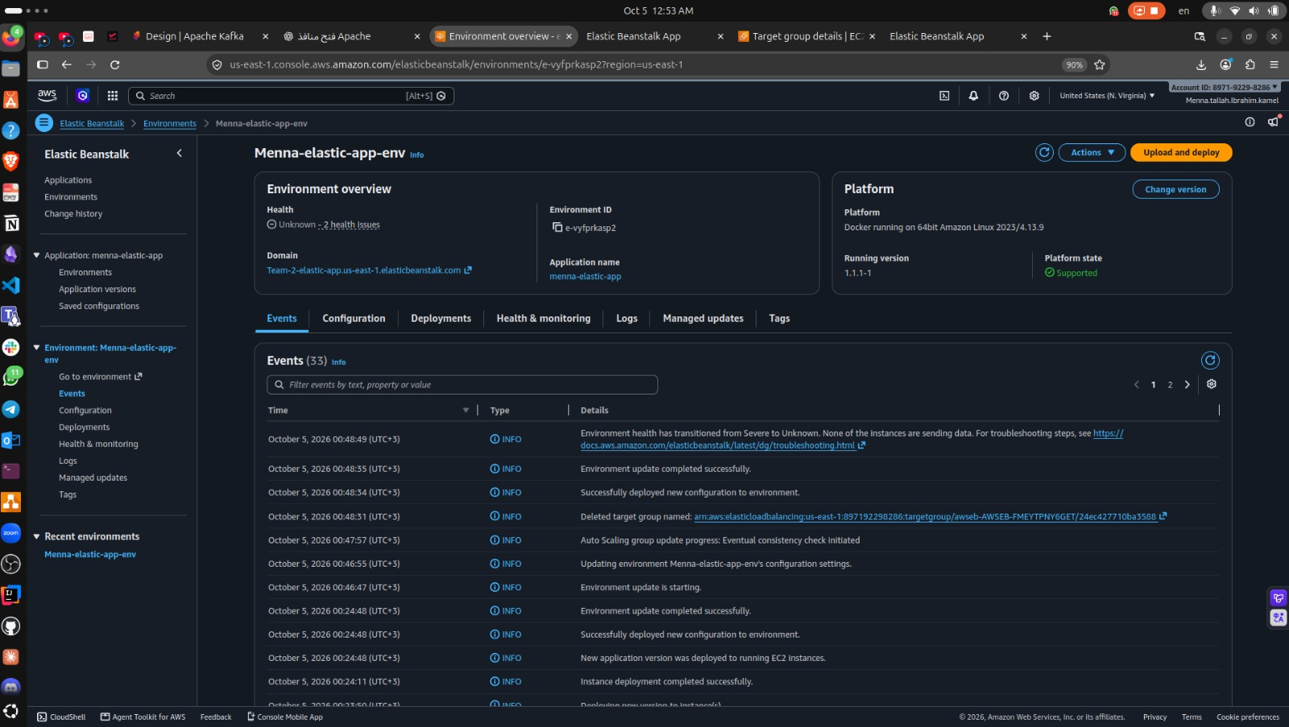
Figure 20: Environment dashboard with health Ok and the environment URL

